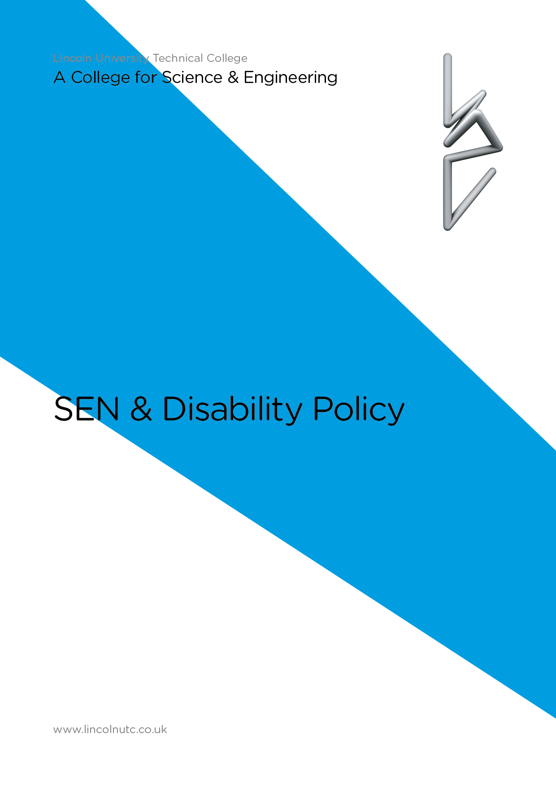
Equality and Diversity Statement

Lincoln UTC strives to treat all its members and visitors fairly and aims to eliminate unjustifiable discrimination on the grounds of gender, race, nationality, ethnic or national origin, political beliefs or practices, disability, marital status, family circumstances, sexual orientation, spent criminal convictions, age or any other inappropriate grounds.

Our legal responsibilities

This policy complies with the statutory requirements laid out in the Special Educational Needs and Disability Code of Practice 0-25 (September 2014) DfE/DoH which requires all schools to ‘have regard to the Code of Practice’ and has been written with reference to the following guidance and documents:

- Children and Families Act 2014
- Equality Act 2010: the college has a statutory duty not to directly or indirectly discriminate against disabled children and young people and must make ‘reasonable adjustments’, including the provision of auxiliary aids and services for them, and the college must have an ‘anticipatory duty’ towards disability.
- Equality Act 2010: Advice for Schools (DfE February 2013): non-statutory advice from the DfE to help schools/colleges understand how the Equality Act affects them and how to fulfil their duties under the Act.
- Working Together to Safeguard Children (2013): Statutory guidance from the Department for Education which sets out what is expected of organisations and individuals to safeguard and promote the welfare of children
- Reasonable adjustments for disabled pupils (2012): Technical guidance from the Equality and Human Rights Commission
- Supporting pupils at school with medical conditions (2014): statutory guidance from the Department for Education
- The Mental Capacity Act Code of Practice: Protecting the vulnerable (2005)

This policy has been written in light of our Safeguarding Policy and has direct links to our policies on behaviour, anti-bullying, medical and curriculum. It was written in consultation with the Governing Body, Principal, current college staff and parents. It should be considered alongside the SEN Information Report as identified in the SEN Information Regulations (Schedule 1 Regulation 51) for this college which can be found on the college website and also alongside the Disability Equality Scheme.

In line with DfE requirements, this policy will be updated every three years unless there is significant change to context or personnel. The SEN Information Report will be updated annually.

The SENDCo at Lincoln UTC is Claire Lowe.

The SEN Governor is James Smith.

The Child Protection Officer is Claire Lowe

Every teacher is a teacher of every child including those with Special Educational Needs and/or disability.

Definition of Special Educational Needs and Disability

The Special Educational Needs and Disability Code of Practice (0-25 years) 2014 states that: ‘A child or young person has SEN if they have a learning difficulty or disability which calls for special educational provision to be made for him or her. A child of compulsory school age has a learning difficulty or disability if he or she:

- has a significantly greater difficulty in learning than the majority of others of the same age; or
- has a disability which prevents or hinders him or her from making use of educational facilities of a kind generally provided for others of the same age in mainstream schools or post 16 institutions’.

‘A child under compulsory school age has SEN if he or she is likely to fall within the definition above when they reach compulsory schools age or would do so if special educational provision was not made for them’.

Many children and young people who have SEN may have a disability under the Equality Act 2010 – that is ‘… a physical or mental impairment which has a long term and substantial adverse effect on their ability to carry out normal day to day activities’.

This definition includes children and young people with long term medical conditions such as asthma, diabetes, epilepsy and cancer. Children and young people with such conditions do not necessarily have SEN, but where a child requires special educational provision over and above the adjustments, aids and services required by the Equality Act 2010, they will additionally be covered by the SEND definition. In addition, we are required to also have regard to statutory guidance regarding supporting pupils with medical conditions (DfE 2014)

Inclusion Statement

At Lincoln UTC we believe every child should have the opportunity to experience success in learning at the highest possible standard. We do this by taking account of pupils’ varied life experiences and needs. We offer a broad and balanced curriculum and have high expectations for all children. The achievement, attitude and well-being of every child matters, and inclusion is the responsibility of every person within our college community.

All children and young people are entitled to an education that enables them to make progress so that they:

- achieve their best;
- become confident individuals living fulfilling lives; and
- make a successful transition into adulthood, whether into employment, further or higher education or training.

Special Educational Needs and Disability Code of Practice, 2014

Policy Principles

In line with the Code of Practice (2014) the Children and Families Act (2014) and the Equality Act 2010, Lincoln UTC is committed to the following key principles:

- All pupils with SEND must have their needs routinely met;
- Raising the achievement of pupils with SEND is a whole college responsibility;
- Early identification and early intervention are essential for ensuring better outcomes for pupils;
- All pupils are encouraged and supported to be active partners in the decision making about their education;
- Active, respectful involvement of parents/carers as equal partners in the education of their child has a positive impact on the learning and well being of their child;
- All pupils with SEND should have the opportunity to learn alongside their mainstream peers in a fully inclusive environment;
- Positive steps and reasonable adjustments are taken to ensure that, where possible, disabled pupils can fully participate in the education provided by the college, and that they can enjoy the other benefits, facilities and services which the college provides for pupils;
- All pupils benefit from ‘Quality First Teaching’: this means that all teachers are expected to assess, plan and teach all children at a level which allows them to progress;
- Collaborative working with external partners and services is essential to ensure we effectively meet pupil need;
- Effective transition arrangements must be in place across all phases of education (and indeed into adult life) to ensure positive outcomes for the pupil and their family;
- Resources allocated to SEND must be effectively used to secure maximum impact and value for money;
- Systems for monitoring and evaluating developments in SEND support improvement in pupil’s learning and provide appropriate challenge.

Our objectives are:
- To identify, at the earliest possible opportunity, barriers to learning and participation for all pupils and make an early, accurate identification of those who may have SEND;
- To work in partnership with parents/carers;
- To value and encourage the contribution of all pupils to the life of the college;
- To ensure that every pupil experiences success in their learning and achieves to the highest possible standard;
- To enable all pupils to participate in lessons fully and effectively;
- To work with the Governing Body to enable them to fulfil their statutory monitoring role with regard to the Policy Statement for SEND;
- To work closely with external support agencies, where appropriate, to further support the needs of individual pupils;
- To ensure that all staff has access to training and advice to support quality differentiated teaching and learning for all pupils.

Principal

- The Principal is responsible for monitoring and evaluating the progress of all pupils and for making strategic decisions which will maximise their opportunity to learn
- The Principal and the governing body will delegate the day to day implementation of this policy to the Special Educational Needs Coordinator (SENDCO)
- The Principal will be informed of the progress of all vulnerable learners and any issues with regard to the college’s provision in this regard through:
  - analysis of the whole-college pupil progress tracking system
  - maintenance and analysis of a whole-college provision map for vulnerable learners as supplied by SENDCo
  - pupil progress meetings with SENDCo and individual teachers
  - regular meetings with the SENDCo
  - discussions and consultations with pupils and parents

Special Educational Needs Coordinator (SENDCo)

In line with the SEN Code of Practice 2014, the SENDCo will oversee the day- to-day operation of this policy in the following ways:
- maintenance and analysis of whole-college provision map for vulnerable learners;
- identifying on this provision map a staged list of pupils with special educational needs – those in receipt of additional SEN support from the colleges devolved budget, those in receipt of High Needs funding and those with statements of Special Educational Need or Education Health and Care plans (EHC);
- co-ordinating provision for children with special educational needs;
- liaising with and advising teachers;
- managing other classroom staff involved in supporting vulnerable learners;
- overseeing the records on all children with Special Educational Needs;
- contributing to the in-service training of staff;
- implementing a programme of Annual Review for all pupils with a current statement of special educational need or EHC. Complying with requests from an Education Health and Care Plan Coordinator to participate in a review;
- carrying out referral procedures to the Local Authority to request High Needs funding and/or an Education Health and Care Plan when it is suspected, on strong evidence arising from previous intervention (additional SEN support from devolved budget), that a pupil may have a special educational need which will require significant support;
- overseeing the smooth running of transition arrangements and transfer of information for all pupils who transfer from one phase of education to another;
- monitoring the college’s system for ensuring that Individual Education Plans, where it is agreed they will be useful for a pupil with special educational needs, have a high profile in the classroom and with pupils;
- evaluating regularly the impact and effectiveness of all additional interventions for all vulnerable learners (including those with special educational needs);
- meeting at least termly with each teacher to review and revise learning objectives for all vulnerable learners in their class who are being tracked on the college’s provision map;
- liaising and consulting sensitively with parents and families of pupils on the SEN list, keeping them informed of progress and listening to their views of progress, in conjunction with class teachers;
- attending area SENDCo network meetings and training as appropriate;
- liaising with the college’s SEN Governor, keeping them informed of current issues regarding provision for vulnerable learners, including those with Special Educational Needs (nationally, locally and within college);
- liaising closely with a range of outside agencies to support vulnerable learners;
- ensuring effective deployment of resources – including teaching assistant support - to maximise outcomes for all groups of vulnerable learners.

Class teacher/subject teacher

- Liaising with the SENDCo to agree:
  - which pupils in the class are vulnerable learners;
  - which pupils are underachieving and need to have their additional interventions monitored on the a vulnerable learners’ provision map – but do not have special educational needs;
  - which pupils (also on the provision map) require additional support because of a special educational need and need to go on the college’s SEN list. Some of these pupils may require advice/support from an outside professional and, therefore, an Individual Plan to address a special educational need (this would include pupils with statements/EHC Plans);
- securing good provision and good outcomes for all groups of vulnerable learners by:
  - providing differentiated teaching and learning opportunities, including differentiated work for any EAL pupils which reduces linguistic difficulty whilst maintaining cognitive challenge
  - ensuring there is adequate opportunity for pupils with special educational needs to working on agreed targets which are genuinely ‘additional to or different from those normally provided as part of the differentiated curriculum offer and strategies.’ (SEN Code of Practice 2014)

SEND Governance
To meet the statutory requirements of the Code of Practice (2014)
- There must be a member of the governing body or a sub-committee with specific oversight of the college’s arrangements for SEN and disability.
- The governing bodies of academies must publish information on their websites about the implementation of the governing body’s policy for pupils with SEN. The information published should be updated annually and any changes to the information occurring during the year should be updated as soon as possible. The information required is set out in the Special Educational Needs and Disability Regulations 2014 and must include information about:
  - The kinds of SEN that are provided for;
  - Policies for identifying children and young people with SEN and assessing their needs;
  - Arrangements for consulting parents of children with SEN and involving them in their child’s education;
  - Arrangements for consulting young people with SEN and involving them in their education;
  - Arrangements for assessing and reviewing children and young people’s progress towards outcomes. This should include the opportunities available to work with parents and young people as part of this assessment and review;
  - Arrangements for supporting children and young people in moving between phases of education and preparing for adulthood;
  - The approach to teaching children and young people with SEN;
  - How adaptations are made to the curriculum and the learning environment of children and young people with SEN;
  - The expertise and training of staff to support children and young people with SEN, including how specialist expertise will be secured.

Evaluating the effectiveness of the provision made for children and young people with SEN:
  - How children and young people with SEN are enabled to engage in activities available with children and young people in the college who do not have SEN;
  - Support for improving emotional and social development. This should include pastoral support arrangements for listening to the views of children and young people with SEN and measures to prevent bullying;
  - How the college involves other bodies, including health and social care bodies, local authority support services and voluntary sector organisations, in meeting children and young people’s SEN and supporting their families;
  - Arrangements for handling complaints from parents of children with SEN about the provision at the college. This should include arrangements for supporting children and young people who are liked after by the local authority and have SEN.

SEN Support: Assess, Plan, Do, Review.
In line with the Code of Practice methodology of Assess, Plan, Do, Review children with SEN are identified as early as possible. Class teachers are continually aware of children’s learning and the progress of every child is monitored half termly. Where a child is identified (assessed) as not making progress, in spite of quality first differentiated teaching, he/she is raised as an initial concern with the SENDCo. These concerns are shared with parents and an immediate plan of action is agreed.
Less than expected progress can be characterised by progress which:
- is significantly slower than their peers from the same baseline
- fails to match or better the child’s previous rate of progress
- fails to close the attainment gap between the child and their peers

There are four distinct categories of SEN need as identified within the Code of Practice 2014:
- Communication and Interaction
- Cognition and Learning
- Social, emotional and mental health
- Physical and sensory

Once a child has been correctly identified with special educational needs, initially the class teacher will meet regularly with the parents/carers to keep them informed of small steps of progress as part of the ‘assess, plan, do, review’ cycle. However, as part of the review process within the Code, regular reviews will be available with the SENDCo. Normally these will be three times a year; more frequent meetings might become necessary if there is a need to move from SEN Support towards a request for statutory assessment for an EHC.

At every stage of the SEN process it is our policy to work in partnership with our parents and their child to secure the best possible outcomes: together we achieve more.

Wherever possible pupils will remain with their class teacher as this is where they l they learn best, with the rest of their class. However, there are times when ‘additional to, different from’ interventions need to be offered to support pupils in in their learning. When any additional support is allocated, whether it is delivered by a teacher, specialist teacher or Teaching Assistant, the focus of all intervention will be on outcomes; our aim is to put in sufficient support to enable all our pupils to reach challenging targets, but without developing a learned dependence upon an adult. All pupils on the SEN register will be supported, monitored and reviewed appropriately; internal assessments will be moderated to ensure validity and reliability. External advice will be acted upon and any additional training to meet needs will be sought, as necessary.

COMPLAINTS

The college works, wherever possible, in full partnership with parents and carers to ensure a collaborative approach to meeting pupils’ needs.

However, all complaints are taken seriously and will be heard through the college’s complaints procedure. In most instances complaints can be resolved at class teacher level. However, if this is not possible, complaints relating to SEN should be addressed to the SENDCo and subequently the Principal.

If a situation remains unresolved then a letter outlining your concern should be sent formally to the Chair of Governors at the college address:

Natalie Smith
Clerk to the Board of Directors
Lincoln UTC
Lindum Road
Lincoln
LN2 1PF

The Chair of Governors is: Mr Gary Headland.

If the normal Governance procedure fails to resolve a situation pertaining to a child with special educational needs and/or disability, then you would need to contact the Local Authority Head of Service for Additional Needs:

Mrs Sheridan Dodsworth
Head of Additional Needs
9-11 The Avenue
Lincoln
LN1 1PA

EQUAL OPPORTUNITIES
The UTC is committed to providing equal opportunities for all, regardless of race, faith, gender or capability in all aspects of college. We promote self and mutual respect and a caring and non-judgmental attitude throughout the college.

REVIEW FRAMEWORK

This policy will be reviewed every three years (or sooner in the event of any legislative change or change of personnel).

Signed:

Principal:

Date:

Signed:

Chair of Governors:

Date:

