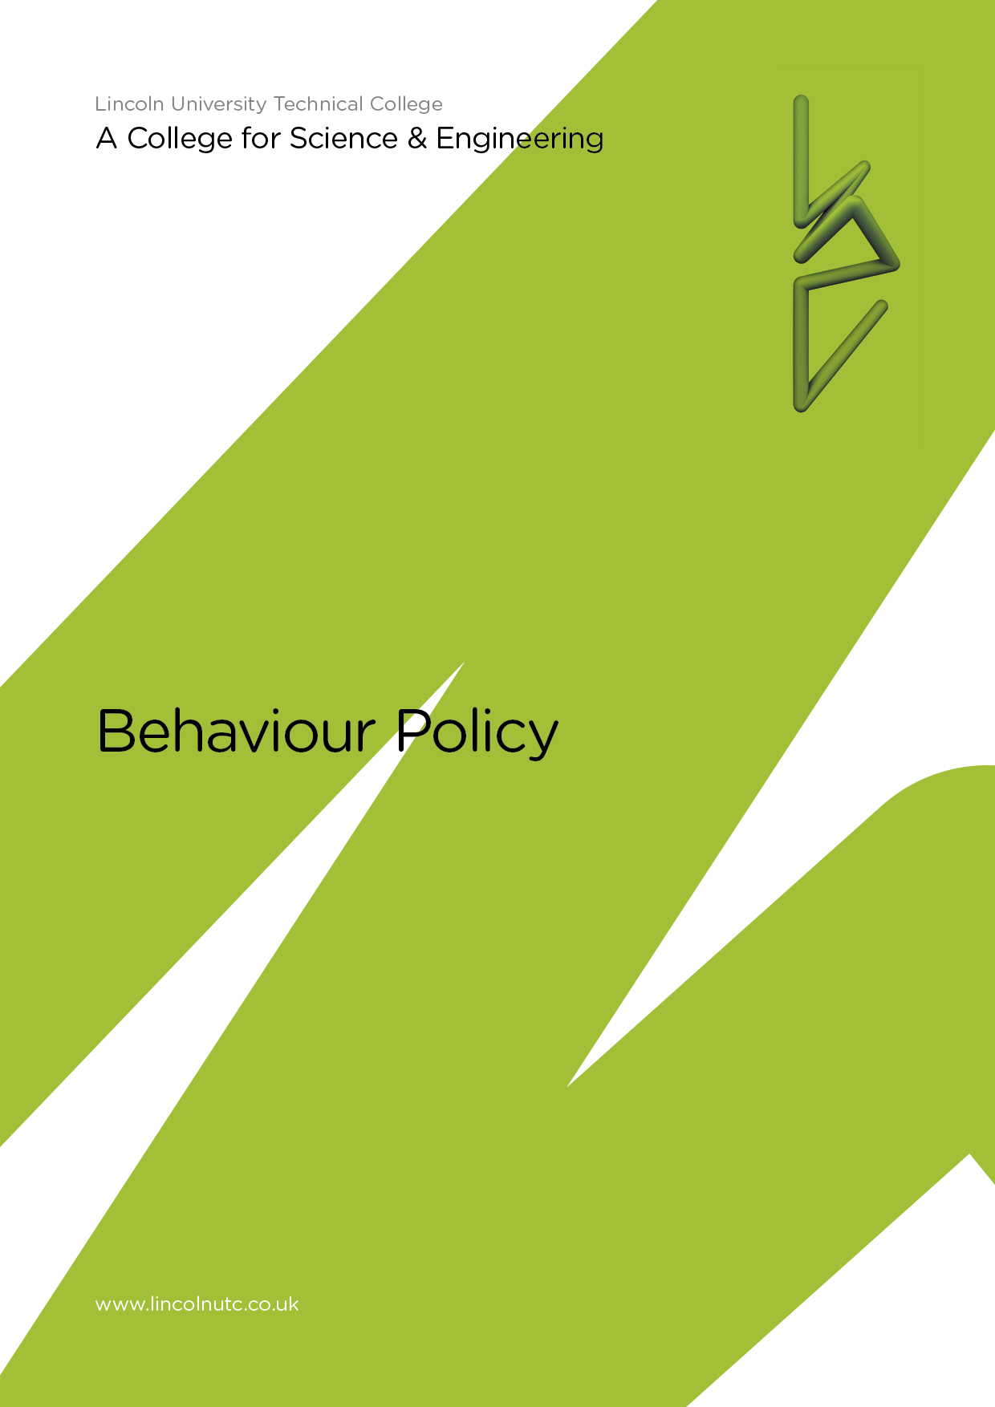

Equality and Diversity Statement

Lincoln UTC strives to treat all its members and visitors fairly and aims to eliminate unjustifiable discrimination on the grounds of gender, race, nationality, ethnic or national origin, political beliefs or practices, disability, marital status, family circumstances, sexual orientation, spent criminal convictions, age or any other inappropriate grounds.

Lincoln UTC

BEHAVIOUR POLICY

CONTENTS

Para | Contents
1 | Introduction
2 | Aims
3 | The Role of the Principal
4 | Promotion of Good Behaviour
5 | Sanctions
6 | Staff Guidance on the Use of Sanctions
7 | Student Referral and the Monitoring of Students
8 | Monitoring Progress
9 | Support in Serious Circumstances
10 | Fixed Term Exclusion
11 | Permanent Exclusion
12 | Recording Behaviour and Sanctions
13 | The use of Physical Restraint
14 | Special Educational Needs and Behavioural Problems
15 | Behaviour Outside of the UTC
16 | The Conduct of enquiries into incidents of bad behaviour
17 | Police Involvement
18 | Making Judgements about the Seriousness of an Offence
19 | Informing Parents

Lincoln UTC

BEHAVIOUR POLICY

1. Introduction

Lincoln UTC recognises that education is a basic right of every individual. Every member of Lincoln UTC will pursue the highest academic and behavioural standards. Lincoln UTC holds the vision of: In pursuit of excellence, we will create supportive, innovative environments and develop professional, respectful relationships. We will seek to achieve this vision by creating an atmosphere which is conducive to learning and supportive to our students. We will actively encourage partnerships with all parents and members of our community in relevant aspects of UTC life by:
- maximising the attainment of all students at all levels;
- improving and striving for excellence;
- connecting education with employment;
- creating the college of the future and embrace new technologies.

In order to do this it is our intention to make available to our students a broad and balanced education, which will:

- give students the opportunities of pursuing particular interests;
- enable students to develop so that they can play a full and active part in society;
- provide knowledge and insights into values and beliefs enabling students to reflect on their experiences in a way which develops their spiritual awareness and self knowledge;
- help students develop lively and enquiring minds with the ability to question and discuss issues rationally;
- give students the skills and confidence to take an increasing responsibility for their own learning;
- develop strategies to ensure full access to the work of Lincoln UTC irrespective of ability, age, creed, culture, gender or race;
- relate the curriculum of Lincoln UTC to the community, providing educational opportunities for all ages and encouraging participation of adults in all aspects of college life;
- create a concern for the community based on tolerance and respect;
- recognise that links with parents, feeder schools, industry, commerce, voluntary organisations and support services are an essential feature of the work;
- develop appropriate in-service training and support for all staff;
- ensure that the work of all staff contributes to the continued development of Lincoln UTC as an integrated community.

2. Aims

This policy aims to:
- provide a policy framework which promotes and reinforces good behaviour and encourages self esteem;
- provide guidance to staff to enable the Lincoln UTC to remain a happy well-ordered learning community where all students can achieve well;
- make clear the UTC’s processes for rewards and sanctions;
- provide a safe environment within which students can enjoy UTC life and achieve well free from bullying or harassment.

In order to achieve the above aims, a series of guidelines have been produced to support their achievement.

3. The Role of the Principal

It is the duty of the Principal to determine and make known measures to be taken to:
- promote, among students, self-discipline and proper regard for authority;
- encourage good behaviour and respect for others;
- secure an acceptable standard of behaviour;
- otherwise regulate the conduct of students;
- ensure that students complete assigned work.

In carrying out these responsibilities the Principal will consult with and, where appropriate, involve staff, governors, students and parents in the consideration of specific aspects of the Behaviour Policy. The Principal should publicise Lincoln UTC’s Behaviour Policy to parents, staff and students annually.

4. Promotion of Good Behaviour
All staff, teaching and non-teaching, have an important role in promoting the good behaviour of students and an achievement culture within Lincoln UTC. In order to promote good behaviour the UTC will:

- articulate a clear vision of expected standards and behaviour in all situations in which the UTC has a responsibility for students, through the UTC’s value system;
- seek to promote a consensus amongst teachers, other staff, parents and students about issues of behaviour and discipline;
- actively seek parental support for maintaining standards by explaining the UTC policy before their children join the UTC through the Home-UTC agreement and by keeping them informed (good news as well as bad);
- explain the required standards to students in a straightforward way;
- staff will model the behaviour they wish to share and, where necessary, teach the behaviour required;
- make effective use of mentor sessions, assemblies, PSHE/Life Guidance and Careers lessons to promote UTC values, and raise issues surrounding equality and multi-cultural awareness;
- recognise the importance of UTC appearance, welcome and comfort and their effects upon student behaviour – this will involve issues of litter, graffiti, vandalism, internal decoration and facilities;
- attempt to intervene at an early stage when behaviour begins to cause concern and, as far as possible, establish links with appropriate and effective support agencies especially in terms of providing support for students;
- follow statutory guidance in addressing behavioural problems especially in terms of special educational needs and students whose behaviour is likely to result in exclusion.

5. Sanctions

Behaviour can depend upon many factors and it is not possible to standardise sanctions relating to behaviour in an absolute manner. However, suggestions have been made as to when sanctions should be 'escalated' in terms of type of sanction and the person applying the sanction in order to communicate the seriousness of the behaviour while still making all possible attempts to 'reform' the behaviour. In order to apply proportional but increasing levels of disciplinary pressure the UTC supports the use of a range of sanctions and a systematic and planned process of referrals. Reference should be made to the stages of the SEN Code of Practice as more people become involved. The UTC will work within legal requirements.

6. Direct Staff Guidance on the Use of Sanctions

Good classroom discipline is the mark of a good teacher: it provides security for teacher and students alike. Every member of staff should feel that they are part of a team which is organised in such a way as to provide support and encouragement at times when teacher/student relationships break down. In order for this support to be given, it is essential that disruptive behaviour, abusive language, laziness, etc., should always be dealt with when it occurs. If bad behaviour is ignored, or tolerated, students believe it is being condoned and will, almost certainly, get worse. All teachers have a right to expect full support from colleagues in times of crisis and stress.

Staff will immediately feedback to students for the following concerns:
- insufficient classwork being completed;
- persistent lateness to lessons;
- poor or disruptive behaviour;
- chewing;
- lack of essential equipment;
- disregard for health and safety procedures;
- persistent uniform or jewellery issues.

These comments will be recorded by the teacher. Where they become a persistent issue, they will be passed to their mentor.

7. Student Referral and the Monitoring of Students

Staff should draw to the attention of the relevant mentor details regarding persistent problems. Mentors may choose to adopt any of the following sanctions, as they deem appropriate:
- informal discussion;
- formal mentoring session;
- monitoring report / feedback from teacher to view progress;
- involvement of peers to provide support;
- involvement of family to provide support;
- mentor report;
- referral to the Head of Key Stage and/or Behaviour and Attendance Officer;
- referral to other agency professionals as appropriate.

Staff have the right to operate a system of detentions of students for lack of work, poor attitude, etc. Such detention must be supervised. It should take part during the college day. It is expected that most detentions will be held during the lunchtime. It cannot last for longer than twenty five minutes. It must focus on a discussion with the student as to the difficulties they are encountering and positive steps that will be taken by the student to ensure the behaviour is not repeated.

8. Monitoring Progress

A three-tier “traffic light‟ system operates at Lincoln UTC in order to monitor the progress of students who are causing concern, as identified by the Teacher, Mentor, Head of Key Stage or a member of SLT.

Green Report – used by Mentor to monitor students on a lesson-by-lesson basis, signed by the teachers and parents. The mentor checks the report daily. The student should not be placed on a yellow report for more than a fortnight without a progress review.

Blue Report – used by the Pastoral Lead to monitor serious concerns about student progress, attendance, punctuality and/or behaviour in a number of subject areas. The Pastoral Lead and parents will monitor the report daily. Parents are advised of the nature of the report via letter and/or telephone. Copies of all correspondence should be placed on the students file.

Red Report – used by the Vice Principal to monitor very serious concerns about general attitude, in response to a serious behaviour issue following a fixed period of exclusion and/or behaviour concerns in a number of areas. The Vice Principal and parents will monitor the report daily. Failure to achieve a positive report could result in immediate internal exclusion or a fixed period of exclusion. Copies of the report should be placed on the student’s file.

9. Support in Serious Circumstances

Support in serious circumstances is provided as part of the UTC’s behaviour management procedures. To operate effectively, it must be used appropriately. It is only used when a real crisis arises which is defined as when:

- a student poses a real threat to the safety of themselves or others:
  - If a student has to be physically restrained we follow the guidelines set out by the DfE:
https://www.gov.uk/government/uploads/system/uploads/attachment_data/file/444051/Use_of_reasonable_force_advice_Reviewed_July_2015.pdf

- Student’s behaviour persistently and genuinely prevents teaching and learning from taking place after all other reasonable strategies to manage the behaviour within the lesson and department have failed.

To access support:

- staff should use the ‘On Call’ shortcut on their desktop;
- a responsible student should be sent to the reception to request support,
- an available member of staff will be alerted by reception and will go directly to the classroom;
- the member of staff will take the student to a venue such as their office or empty classroom where work is undertaken, with appropriate supervision;
- the member of staff ensures that the SIMS behaviour log is updated;
- the issues of concern, which led to the call, are discussed and the student encouraged to take responsibility for their actions. Restoration of relationships between staff and students takes place prior to reintegration into the lesson. This may be managed by the Head of Key Stage, Mentor, Behaviour and Attendance Officer or member of SLT as appropriate;
- where there is persistent and cross-curricular disruption, the Head of Key Stage will contact home and further steps will be taken to provide appropriate sanctions and support.

10. Fixed Term Exclusion

Only the Principal (or the Vice Principal in loco standi) has the power to exclude a student. It is a serious sanction to invoke against any young person and no students should be told by word of mouth or writing by any other member of staff that they have been or will be excluded.

Students may be given fixed term exclusion for serious breaches of behaviour.

There are very clear guidelines regarding exclusion. Of paramount importance is effective liaison with parents, governors, the Local Authority and other outside bodies. In order for these avenues to be fully explored it is important that effective and full records are kept on any student whose behaviour is such that it may lead to future exclusions.

Where exclusion is being considered a meeting will usually be called involving the student’s mentor, Head of Key Stage and other relevant members of staff. For a first exclusion the meeting will be chaired by the Vice Principal. Subsequent meetings may be chaired by the Principal. When a student is excluded they will not be readmitted to UTC until the seriousness of the matter has been discussed with parents. Under no circumstances will a student be allowed back into UTC without specific undertakings from the student and parents.

In cases where exclusion is for more than fifteen days a much more formal involvement of the Governing Body and LA is required. In these very serious situations it becomes increasingly likely that the exclusion will be made permanent. When a student is excluded colleagues are asked to provide work to be done at home. This is a legal requirement. The work is handed to Reception. A fixed term exclusion can be given for up to a maximum of 45 days in one academic year.

Parents are requested to attend an interview on the student’s return from fixed term exclusion with the Mentor and/or Behaviour and Attendance Officer and/or Head of Key Stage and/or the member of SLT. A Pastoral Support Programme (PSP) may be produced for students following fixed term exclusion.

11. Permanent Exclusion

The following misdemeanours, which is non-exhaustive, could merit permanent exclusion, though each case will be dealt with on an individual basis:

- Racial harassment;

- Sexual harassment;
- Persistent bullying and intimidation;
- Physical assault;
- Possession or use of illegal substances;
- Possession or use of legal highs;
- Selling illegal substances;
- Possession of articles which could be used as offensive weapons;
- Theft of student or college property;
- Inappropriate use of social media platforms;
- Malicious damage to college property;
- Conduct which brings the good name of the college into disrepute when travelling to and from college in uniform, or whilst representing the college in sporting events/work placements or as a member of a college party;
- Persistent misbehaviour which over a period of time is disruptive to good order in the college and has a detrimental effect on the learning of other students.

When considering exclusion we follow DfE guidance:
https://www.gov.uk/government/uploads/system/uploads/attachment_data/file/269681/Exclusion_from_maintained_schools__academies_and_pupil_referral_units.pdf

12. Recording Behaviour and Sanctions

Minor, frequent incidents, and more seriously unacceptable behaviour, should be logged using UTC procedures on SIMS.

13. The Use of Physical Restraint

Staff should avoid all use of physical chastisement and the use of physical restraints unless students are in danger of harming themselves or others or causing serious damage to equipment or property. In such cases physical restraint will be kept to the minimum required. If physical restraint is used the incident should be logged and reported immediately to the Principal. Full guidelines for the use of restraint can be found on the DfE website:
https://www.gov.uk/government/uploads/system/uploads/attachment_data/file/444051/Use_of_reasonable_force_advice_Reviewed_July_2015.pdf

14. Special Educational Needs and Behavioural Problems

In managing behaviour difficulties of individual students the UTC should have regard to the Code of Practice for Children with SEND and will strive to ensure that failure to identify and meet the special learning needs of some students is not the cause of bad behaviour.

Students identified as having special educational needs with regard to behaviour should be given support, and, where appropriate, provided with opportunities to improve through support from external agencies.

15. Behaviour Outside of the UTC

Students’ behaviour outside the UTC whilst on UTC “business”, for example trips and journeys, sports fixtures or a work experience placement is subject to the UTC’s Behaviour Policy. Poor behaviour in these circumstances will be dealt with as if it had taken place in the UTC. For behaviour outside the UTC but not on UTC business, this policy will still have effect if there is a clear link between that behaviour and maintaining good behaviour and discipline among the student body as a whole. If students’ behaviour in the immediate vicinity of the UTC or on a journey to and from the UTC is poor and meets the UTC criteria for exclusion then the Principal may decide to exclude.

16. The Conduct of Enquiries into Incidents of Bad Behaviour

Disciplinary enquiries often operate within a number of constraints:
- those who feel aggrieved want to see justice done;
- parents may refuse to accept their child has done wrong;
- blame may not be all on one side;
- absolute proof about what happened may not be available;
- expectations may be unrealistic;
- staff time to pursue an enquiry is limited.

UTC discipline enquiries will be conducted within the context of:
- 'loco parentis' (not as a legal enquiry). i.e. conclusions may be reached upon an assessment of the whole situation and a knowledge of the students involved and not necessarily upon absolute proof.
- a reasonable response in terms of:
  - the amount of time given to the enquiry;
  - balancing probability when absolute proof is not possible;
  - assessing the relative reliability of witnesses on the probability of them telling the truth or not;
  - the consistent application of policies.

Students should learn from experience to expect fair and consistently applied punishment for bad behaviour which clearly makes the distinction between serious and minor offences. Care should be taken to avoid scapegoating.

Within an enquiry the statement 'I do not believe you' may be based upon a balance of probability not upon absolute proof. Standards of UTC discipline have to be maintained and it would be quite harmful to develop a culture in which those who honestly own up are punished whilst those who lie get away with bad behaviour.

If within an enquiry students or their parents raise wider issues which they believe has contributed to the incident/s of bad behaviour the UTC will take reasonable steps to investigate.

Amongst other information it is important to clarify as a result of any investigation:
- previous behaviour record in UTC - If student has a poor record what previous steps have been taken?
- is the student considered to have an SEMH or are there any external factors which should be taken into consideration?
- was the incident perpetrated by the student on his/her own or as part of a group?
- if within a group is there evidence that the particular behaviour was more remiss than that of other members of the group?
- from where did the evidence come about the students' involvement in the incident?

17. Police Involvement

In the event of the police becoming involved in an enquiry the UTC may consider it to be appropriate to allow them to complete their enquiries and decide upon the action they propose to take before completing the UTC enquiry. A likely exception would be if, for the safety of the UTC community, it was decided to exclude a student.

There may be circumstances in which the UTC makes the decision to involve the police as a result of incidents which have occurred within UTC.

18. Making Judgements about the Seriousness of an Offence

The UTC will assess as serious incidents which:
- bring danger, threat or intimidation to self or others;
- are judged to seriously undermine the standards upon which the UTC Value system is based or to bring the reputation of the UTC into disrepute;
- involve repeated disruption, defiance or rudeness;
- cause serious deliberate damage.

In order to help maintain a proportional approach a seriousness assessment should be completed in which the incident itself should be considered on a scale of proportionality and the likelihood of repetition similarly assessed. The appropriateness of any sanction should, in part, be based upon such an assessment.

Examples of bad behaviour likely to be regarded as serious:
- repeated defiance;
- poor behaviour whilst in isolation;
- assault;
- bullying;
- rudeness to a member of staff;
- verbal abuse of any member of staff;
- total loss of control, including hitting out and swearing;
- misuse of the fire bell;
- theft or serious damage;
- illegal acts like the possession of cannabis or a knife;
- combinations of the above;
- where there is a necessary deterrent value and other measures have failed to have an impact;
- where a student is “re-offending” and all other methods to bring about a change in the student’s behaviour have failed.

19. Informing Parents

We seek to work in co-operation with parents. It is general policy to bring all incidents of serious bad behaviour to the notice of parents. Parents will be notified of less serious incidents if punishment will entail after UTC detention or if on general welfare grounds it is judged appropriate by staff to inform or discuss the issue with the parent. A simple example of this would be informing parents of non-completion of homework through a message in the student planners. In the event of exclusion every effort will be made to inform parents prior to the student going home with news of the exclusion. It may be appropriate to defer the final decision about exclusion until after parents have been contacted

Policy reviewed April 2019

