Equality and Diversity Statement

Lincoln UTC strives to treat all its members and visitors fairly and aims to eliminate unjustifiable discrimination on the grounds of gender, race, nationality, ethnic or national origin, political beliefs or practices, disability, marital status, family circumstances, sexual orientation, spent criminal convictions, age or any other inappropriate grounds.

Lincoln UTC

CAREERS EDUCATION, INFORMATION & GUIDANCE Policy

CONTENTS

Para | Contents
1 | Policy Statement
2 | Provision
3 | Information
4 | Additional Advice
5 | Place within the Curriculum
6 | Assessment and Review
7 | Evaluation
8 | Equal Opportunities
9 | Work Experience
10 | Evaluation and Monitoring

Lincoln UTC

CAREERS EDUCATION, INFORMATION & GUIDANCE Policy

1. POLICY STATEMENT

Lincoln UTC seeks to ensure that each young person, whatever their background, ethnic origin or ability, is as fully prepared as possible for the transition to further education, training or employment. The policy is based on the belief that the development of self-perception and self-confidence, which is fundamental for all individuals participating in careers education. This is fostered throughout the UTC, through all lessons as well as the delivery of Life Guidance. We encourage students to participate in a wide range of enrichment activities both in the UTC and outside.

This policy has been informed by the following documents:

- Careers Guidance and access for Education and Training Providers
DfE, January 2018

- Careers Guidance in Schools and Colleges: A guide to Best Practice and Commissioning Independent Career Guidance Services
CDI, June 2018

- Good Career Guidance
The Gatsby Charitable Foundation

This policy applies to all members of the UTC community. Lincoln UTC is fully committed to ensuring that the application of this Careers Policy is non-discriminatory in line with the UK Equality Act (2010). Lincoln UTC seeks to implement this policy through adherence to the procedures set out in the rest of this document. The governor responsible for the oversight of this policy and Careers within the UTC is
Mr Frank Carchedi.

2. PROVISION

Careers education is delivered throughout the UTC and in line with the GATSBY Benchmarks. Career sessions are delivered as part of our Life Guidance programmes in Years 10 to 13.

Please refer to appendix 1 for the Student Careers Entitlement document.

All year groups are given a Work Experience opportunities. This is a compulsory week in Years 10, 11, 12, and 13.

Students in Year 10, 11 and 12 participate in ‘Projects’ throughout the week and these sessions allow students to develop skills in many areas, such as:
- Confidence in presenting
- Teamwork
- Collaborative working
- Problem solving

Students in Year 12 and 13 participate in Life Guidance on a weekly basis. These lessons help our students broaden their knowledge about many topical issues. As well as this all students are given advice on Post-18 Options including apprenticeships and Higher Education options. Lincoln UTC allows students to attend careers fairs for further information advice and guidance.

Students in Year 12 and 13 are also invited to weekly Business Lunches that are organised weekly and overseen by the Head of Sixth Form. These Business Lunch events are opportunities for our side agencies / companies to attend the UTC and meet our students informally over lunch. Discussions are held

Specific future Careers Guidance is organised within Year 11 and 13 and is provided by an external careers specialist. All students will have the opportunity to seek advice from an independent and impartial professional.

Careers Education is undertaken in the following ways:

- Delivery of a broad and balanced Careers Education curriculum which attempts to meet the needs of all students and encourages the development of:
- Awareness of their own personal qualities and those of others.
- Self-esteem and a balanced view of their potential.
- Self-reliance and a positive attitude to life.
- Knowledge of the full range of opportunities available to them from the age of 14 years through to 19 years.

- A structured programme of Careers Education to:
- Help students and their parents to understand the range of 16+ and 18+ options.
- Allow students to meet local employers.
- Ensure all are aware of their rights and responsibilities as adults.
- Provide experience of different working environments.

- Provision of opportunities at the UTC for students to:
- Develop decision-making processes.
- Develop those key skills needed to live and prosper in the adult world.
- Continue to develop positive attitudes to life and each other, which the whole UTC ethos encourages.
- Have open access to a variety of careers information and guidance.
- Understand the opportunities available to them in their future lives.

- Agreeing a Career Action Plan and work in partnership with independent careers advisors:
- Compliment and support the UTC’s programme of careers education.
- Provide impartial advice and guidance to all students and parents from the time the pupil reaches Year 10 through to Year 13.
- Help with personal action planning and the production of a career plan.
- Ensure that students have access to materials providing careers guidance and to a wide range of up-to-date reference materials including lifestyle information.

3. INFORMATION

The coordination of careers will provide relevant information to our students so that they are able to may positive and informed decisions about their future. Facilities are made available to all students within college to access the resources that are needed for them to widen their knowledge and understanding of opportunities available to them after the UTC.

4. ADDITIONAL ADVICE

The Careers coordinator will:
- Organise and attend careers fairs;
- Give advice at Year 10, 11, 12 and 13 parent consultation evenings;
- Organise appropriate opportunities for a careers professional to be available a points during the year.

5. PLACE WITHIN THE CURRICULUM

Careers Education is an integral part of the college curriculum. Careers Education is offered as:

- An integrated aspect of the Life Guidance programme in all years.
- Specific careers events across the whole college, aimed at transition points.
- Individual support for Years 12 & 13.
- Specialist events.

6. ASSESSMENT AND REVIEWING OF CEIAG

- Career planning reviews with tutors, Pastoral Leaders and the Careers coordinator forms part of the recording of the achievement process.
- Evidence is provided through:
- Career Action Plans produced from Guidance Interviews
- Career evaluation from Work Experience
- Career interview feedback
- Life Guidance overview (Gatsby Benchmarks)

7. EVALUATION

The provision and effectiveness of the CEIAG programme is monitored by the Careers coordinator and Heads of Key Stage through a variety of procedures:
- Feedback from: Students, Parents, External Advisers, Mentors and Employers linked with work experience:
  - Feedback will be gained using a variety of methods e.g. online and paper questionnaires, formal evaluation sheets, informal discussions.
- The programme of careers education information and guidance forms an integral part of the whole education from a suitably qualified adult and aims to empower students to make a positive contribution to the community in which they live.

8. EQUAL OPPORTUNITIES IN CAREERS EDUCATION, ADVICE & GUIDELINES

Equality of opportunity is sought by:
- Making sure each student is directed towards the Careers Policy on the website at the beginning of each academic year.
- Year group’s Careers Handbook.
- Providing equal access to all work experience placements irrespective of gender, race or ability
- Students are encouraged to undertake work related activities outside traditional gender roles
- All students are encouraged to investigate a wide range of job opportunities, outside traditional gender roles
- By linking the CEIAG Policy in with the Life Guidance / PSHE provision as well as the college’s Equal Opportunity Policy

9. WORK EXPERIENCE

Lincoln UTC seeks to ensure that each student, whatever their background, ethnic origin or ability, undergoes work experience/ work inspiration placements during Key Stage 4 & 5.

Work experience takes place on occasions when students, not under the direct supervision of a teacher, spend time at a place of work away from college. During this time they carry out particular activities in the work place or assigned to observe employees going about their normal tasks.

Work Experience information is initially provided to Y10 students in readiness for Y10 placements and allowing sufficient time for the student to make arrangements. Work Experience information and placements are coordinated by Mr Little. Lincoln UTC is not responsible for risk assessments for each student placement, but ensures each placement has the appropriate employer’s liability insurance and asks if there is a young person’s risk assessment in place at the company for the placement.

Lincoln UTC involvement includes:
- Encouraging students to take up placements and think beyond stereotypical roles
- Developing students awareness of Health and Safety issues
- Evaluation/student feedback of the placement via students and tutors

Student/parental involvement includes:
- Ensuring that the employer has the legal insurance cover for accepting students on work experience
- Ensuring a copy of the employer insurance details and a copy of their risk assessment is received
- Parents/Guardians must ensure the employer has contact details for them in case of an emergency
- Students are encouraged to undertake activities outside traditional gender roles

Aims of Work Experience:
- To empower students to make a positive contribution to society
- All students to experience of the world of work
- To build upon and develop existing economic and industrial understanding

10. EVALUATION & MONITORING

Work experience placements will be monitored and evaluated:

- Contact will be made with all work experience placements to ensure effectiveness of the placement.
- Most of the work experience placements will be personally visited by Lincoln UTC staff to ensure quality of placements.
- All Work Experience placements are contacted via email following placements for specific feedback and suggestions for the future.
- Presentations based on work experience will be developed within the English curriculum.

Document reviewed: Sept 2018
Document updated: Apr 2019

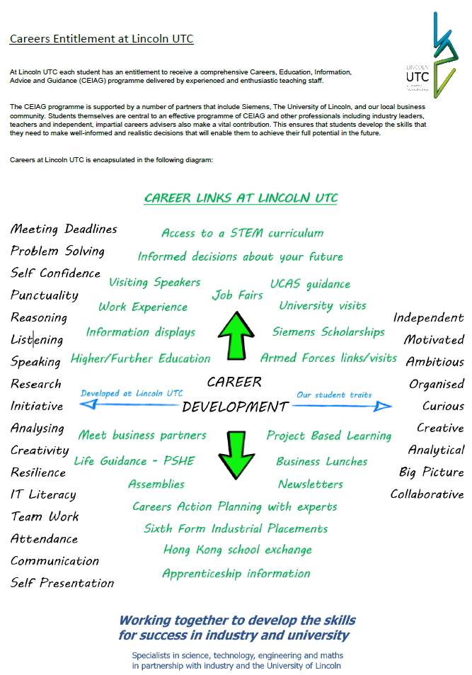
Appendix 1: Student Careers Entitlement

