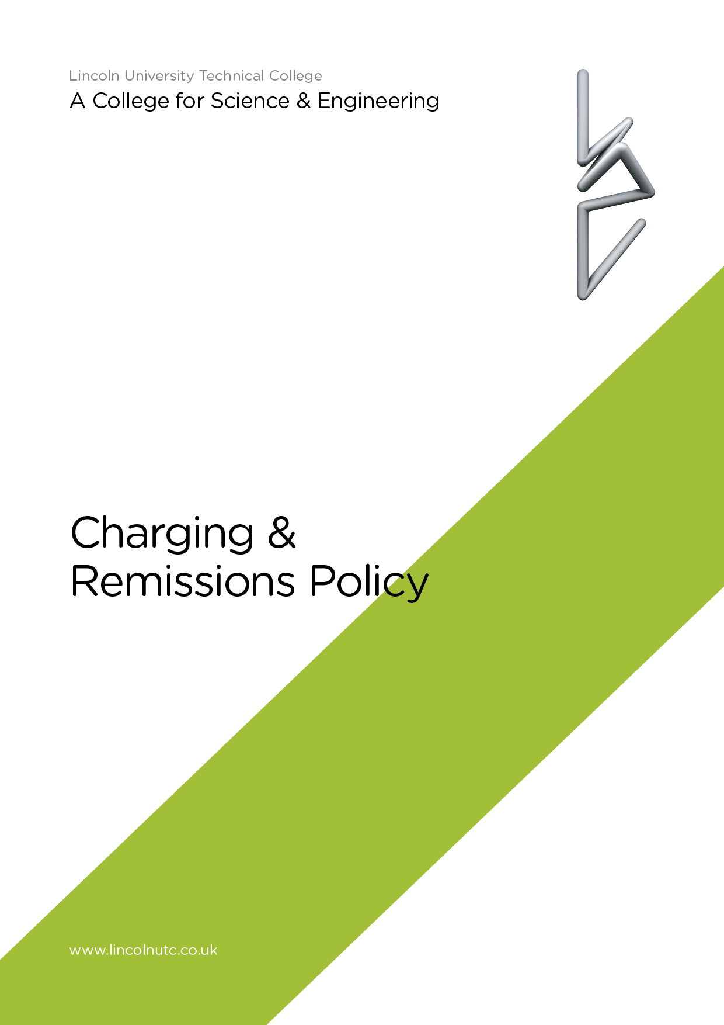

Equality and Diversity Statement

Lincoln UTC strives to treat all its members and visitors fairly and aims to eliminate unjustifiable discrimination on the grounds of gender, race, nationality, ethnic or national origin, political beliefs or practices, disability, marital status, family circumstances, sexual orientation, spent criminal convictions, age or any other inappropriate grounds.

LINCOLN UTC

CHARGING AND REMISSIONS POLICY

1. Monitoring, Evaluation and Review
The Principal and Board of Directors will review this policy in line with the policy review cycle and assess its implementation and effectiveness. The policy will be promoted and implemented throughout by Lincoln UTC.

2. Introduction

Lincoln UTC recognises the valuable contribution that the wide range of additional activities, including clubs, school visits, residential and experiences of other environments, can make towards students’ all round educational experience and their personal and social development.
3. Charging
Lincoln UTC reserves the right to make a charge in the following circumstances for activities organised by the college:
- College visits including residentials in college time: the board and lodging element of the residential experience and outdoor pursuit courses.
- Activities outside college hours: the full cost for each student of journeys, trips and overnight stays in the United Kingdom and abroad which take place at weekends and during holidays.
- Acts of vandalism and negligence: Lincoln UTC reserves the right to recover part, or the whole cost, of damage to buildings or equipment which is the result of vandalism or negligence by a student.
- Examination fees: if a student has not regularly attended the lessons for a particular examination subject, the examination fee may be requested, refundable if the student attends for examination.
- If, without a medical certificate explaining the reason, a student fails to complete examination requirements for any public examination for which the UTC has paid an entry fee, the Board of Directors may seek to recover the fee from the parent.
- There may be a charge for examination entry where there is a request from the parent for additional subject entries or re-sits to be made which are not supported by the UTC.
4. Remissions
Where the parent of a student is in receipt of qualifying state benefit(s), Lincoln UTC may remit in part the cost of board and lodging for any residential activity that is organised for the student and which takes place within school time. This will also be the case where the residential activity forms part of the syllabus for a public examination.
5. Insurance
Any insurance costs for personal injury will be included in charges made for trips or activities.
6. Voluntary contributions
Nothing in this policy statement precludes Lincoln UTC from inviting parents to make voluntary contributions. Lincoln UTC should make clear that such contributions are voluntary; those children of parents who do not contribute will not be discriminated against. If insufficient contributions are received the trip may be cancelled.
Document reviewed: Sept 2018

