***Where are they now?***

***Year 11 student destinations***

***2018***

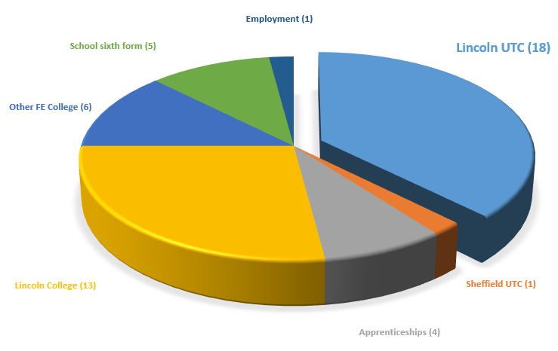

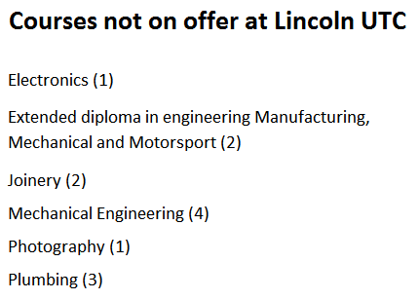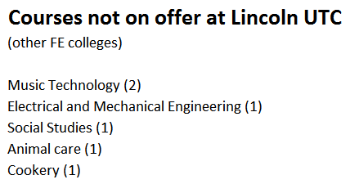

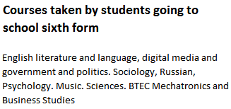

***Working together to develop the skills for success in industry and university***

Specialists in science, technology, engineering and maths

in partnership with industry and the University of Lincoln

