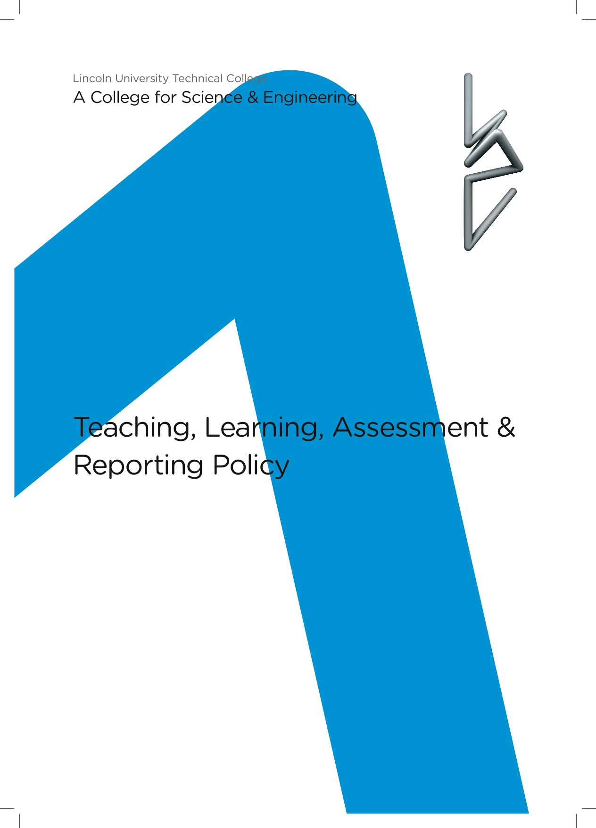

Equality and Diversity Statement

Lincoln UTC strives to treat all its members and visitors fairly and aims to eliminate unjustifiable discrimination on the grounds of gender, race, nationality, ethnic or national origin, political beliefs or practices, disability, marital status, family circumstances, sexual orientation, spent criminal convictions, age or any other inappropriate grounds.

TEACHING, LEARNING, ASSESSMENT and reporting policy

 | Contents
1 | Aims
2 | Target setting
3 | Assessment measures and tracking
4 | Developing the student as an effective learner
5 | Ideal teaching
6 | Assessment and feedback
 | Appendices

1 Aims

The aim of this policy is to define what Lincoln UTC believes is the basis for effective Teaching, Learning, Assessment and Feedback. This document will guide teachers on what to do in order to facilitate progression for all students leading to excellent outcomes. This policy also gives an overview of the ways in which targets will be set for students’ attainment and how students’ progress will be assessed, monitored and reported.

2 Target Setting

- Minimum expectation
- Personal target

Minimum expectation
Minimum expectation is based on published national average figures for KS2 to KS4 progress. The start point for calculating this measure is the individual student’s KS2 fine level (average of English and maths). The national average data then provides an estimate of the student’s likely attainment, split into ‘Attainment 8’, English, maths, EBacc and open attainment. In most cases this will fall between two integer values. Students cannot achieve anything other than an integer value. If, for example, the national average for a KS2 prior attainment band is 4.56 then we would choose the higher of the two grades. The ‘minimum expectation’ would be a grade 5. In all cases we would choose the higher of the two grades … not round to the nearest whole number. A national average figure of 5.20 would result in that student having a minimum expectation of a grade 6. There is, therefore, a level of challenge and aspiration within the minimum expectation.

Personal target
Use of KS2 data and national average figures for progress can only provide a rough guide to a student’s potential or likely outcomes. KS2 results are just based on English and maths and as such not always the best indicator of likely performance in other subjects. Primary school pupils are often markedly different in their maturity and their KS2 results can vary as a consequence. Although some of the minimum expectations may be challenging for individual students (due to rounding up) they are still based on average rates of progress. We shouldn’t be encouraging students to aim for being average. Students are encouraged to set their own personal targets for each subject they study. These should ideally be set after discussion with subject teachers. Whilst targets should be aspirational, they should also be realistic. In some cases, students may have the same grade as a personal target as their minimum expectation.

In exceptional cases, students may be permitted to set personal targets which are lower than the minimum expectation grades derived by the methodology outlined above. We acknowledge that KS2 outcomes can occasionally lead to students having targets set which are so unrealistically challenging as to be unachievable and, therefore, de-motivational. The number of cases in which this will be appropriate will be extremely low and students will not be permitted to set low personal targets without the approval of the head of key stage, who will look carefully at each case and at the individual’s baseline (GL Assessment) data.

KS5 Targets
Key Stage 5 targets will be set according to the individual student’s KS4 GCSE point score and using national data for KS4 to KS5 progress. Published ‘Alps’ data tables which show student progress at different thresholds will be used to assign targets. Targets will be set at the 75th percentile (in line with what would be expected for that student if he or she was in the top 25% for KS4 to KS5 progress). Alps generated targets are generally accepted as being appropriate in terms of level of aspiration and challenge and are not subject to the same concerns (inaccuracy and inappropriateness) which affect KS2 based targets. Key Stage 5 students do not have separate ‘minimum expectation’ and ‘personal targets’.

3 Assessment measures and tracking
Students’ attainment and progress will be formally assessed and tracked four times in each academic year (in addition to the ongoing assessment in lessons). Each of the four data collection points will generate a progress report which will be shared with students and sent to parents and carers. At each of these points, the measures which will be recorded are as follows.

- Working at grades (WAGs)
- Predicted grades
- Attitude to learning

Working at grades (WAGs)
Working at grades (WAGs) are the most important measure with which we track student progress. WAGs are a current performance measure. There is no predictive component within the WAG. WAGs should always be thoroughly evidence based. Where possible the evidence base for producing the WAGs would be past paper practice using questions which come with published mark schemes and grade boundaries. The students should ideally complete the assessments which inform the WAGs under examination conditions. Assessments should be significant in terms of the length or volume of work required (1 hour practice tests rather than shorter tests). The marking of these key assessments must be moderated with records kept. Whilst the assessments may include recent topics covered by students (end of topic testing) they should also include some synoptic assessment of all the work carried out since the student embarked on the course. Over-reliance on end of topic testing inflates grades as students will score more highly on work that is still fresh in their mind. Ideally, tests should be designed to cover all work covered by the students with relative weightings for the different topics that are representative of what the students would get in ‘the real thing’.
In subjects that have a coursework element the assessment of and evidence base for the WAGs should include both an evaluation of coursework and of the students’ performance in the components that will be examined. WAGs should be based on all coursework units completed rather than just the most recent. The marking of coursework must be moderated with records kept.

Predicted grades
Predicted grades are the teacher’s prediction for the final outcome. Whilst they will be informed by the WAGs they also allow for professional judgement. Predicted grades may be lower than WAGs if the content covered to date (on which WAGs are based) does not include more challenging topics which students historically do less well on. Predicted grades may be higher than WAGs if, in the judgement of the teacher, students are likely to improve upon their previous grades as a result of further exam practice, revision and engagement with intervention activities.
The pattern may well be different for different subjects. In some subjects (science and maths?) students’ performance in previous and recent topics may well be a good indicator of their likely performance in the terminal examinations. (If the student achieved a grade 6 for the work that they did on ecology last term it would suggest that they would be likely to replicate this when answering questions on this topic in their exams). If so, it is likely that there wouldn’t be a great deal of difference between the WAGs and the predictions. In other subjects (English?) the students marks may be more heavily influenced by the way in which they develop their skills over an extended period of time. It may be that WAGs are low throughout year 10 and the beginning of year 11 as students may, despite having good understanding, not yet have mastered the writing technique or evaluative skills required to access the higher marks. In some subjects, therefore, there may be larger gaps between the WAGs and the predictions.

Attitude to learning
Scored on a 1 to 4 scale: Outstanding (1), Good (2), Requiring improvement (3), Inadequate (4).
Attitude to learning covers all aspects of the students approach to work in lessons. It incorporates effort and behaviour. It should also consider the extent to which the student works well with others in the class and is willing to work and learn collaboratively. Judgements on attitude to learning will also be a reflection on the standards that student sets for himself or herself in terms of the quality of and the presentation of their work. The Outstanding rating (1) should only be given to students who routinely impress the teacher by going above and beyond what is expected … students who are active participants in the lesson, who have the highest standards and a phenomenal work ethic. A student who is generally quiet and well behaved, who does all that is asked of them might be ‘good’ but wouldn’t be outstanding’.

4 Developing the student as an effective learner
(The Ideal Student)

Good and outstanding teaching is about much more than filling our students’ heads with facts and preparing them for examinations. It is about helping them develop and grow as individuals who will become effective life-long learners. If we are successful supporting our students in developing these skills then the outcomes and the examination successes will follow as a consequence. As teachers, we must be constantly mindful of the traits and learning behaviours that we are trying to promote and develop. One of the most important things that we can do is to constantly reflect on our practice to ensure that our planning provides students with frequent and regular opportunities to practise and develop these skills … the skills of the ‘Ideal Student’.

The Ideal Student

- The ideal student is curious. He wants to make sense of the world around him. He has the capacity for awe, wonder and amazement. He wants to understand everything.

- She knows what is important to her and ‘what makes her tick’. She arrives at all lessons motivated and committed. She is an active participant in lessons. She does not rely on others (teachers) to provide her motivation.

- He has high levels of personal organisation. He plans carefully and makes good use of his time, hitting all deadlines.

- She is independent and does not regard herself as a hollow vessel waiting to be filled with the information necessary to pass her exams. She does not wait to be spoon fed. She wants to find things out for herself.

- He works well with others, listens to others and appreciates that he can learn most effectively when learning is a collaborative activity. He treats others with respect at all times.

- She is analytical in her thinking ... able to construct a convincing argument for her views and opinions. She always explains her thinking and justifies her reasoning.

- He always tries to connect his learning to work done before and work that he knows is coming. He tries to link all new learning … to real life contexts, to his own life experience and to academic work in other subjects.

- She is a creative thinker who is willing to ‘think outside the box’. She is happy to take risks and try new things.

- He sets ambitious targets for himself and is willing to do whatever it takes to realise these goals. He routinely reviews his progress towards these targets. He asks for feedback as part of this process.

- She isn’t afraid to get things wrong. She is resilient … always ready to ‘get back on the horse’ and try again. She learns from her mistakes, corrects all her work and responds positively to constructive criticism. She perseveres when things are tough and doesn’t give up quickly or easily.

Advice for students …
How to become the Ideal Student

- Be curious. Try things out. Ask lots of (appropriate) questions.
- Think about what you want to achieve whilst at the UTC and approach every lesson with a positive attitude.
- Get organised. Plan your work and use your time productively.
- Take responsibility for your own learning. Try to find things out for yourself.
- Strike a balance between putting forward your ideas and taking the time to listen to others. We can all learn from listening to others.
- Ask yourself ‘why?’ and ‘how?’ as often as you can. Explain your thinking and justify your reasoning.
- Think about how the new things you learn link to other subjects and to real life situations.
- Have a go at doing things differently or taking a different approach.
- Aim high. Set challenging targets for yourself and regularly check how you are doing in relation to these targets.
- Don’t be afraid to get things wrong and make mistakes. Learn from your mistakes and try again.

5 Ideal teaching

- Lessons should have clear objectives, communicated to students. Where possible, the relevance and importance of the lesson should be made clear by linking lessons to previous work, to future work and to the wider world.

- Teachers should be consistent in their dealings with students and have clearly communicated expectations with regards to conduct and learning behaviours. We should be quick to recognise, praise and reward the behaviours we would wish to promote.

- Teachers should deliberately and consciously employ a variety of teaching and learning styles and be open to trying new things.

- Open questions are incorporated into lesson plans wherever possible and the students’ responses to them are valued.

- Active, independent and collaborative learning should be encouraged (students doing things for themselves and thinking for themselves).

- Work set should be challenging and encourage students to live up to the high expectations we have in terms of both work rate and quality of work.

- Teachers should know their students as individuals and tailor the learning experience to meet their individual needs. Lessons in which all students are set the same work are occasional, deliberate choices rather than the default mode.

- Lessons and learning are pacey. High pace is achieved in parallel with strong AfL practice in which the teacher checks for understanding before moving on … no student is left behind.

- Tasks for students are designed to allow them to fail and then learn from their mistakes in a safe and supportive environment.

- Constructive feedback, explicitly linked to success criteria, should be given through discussion and the regular, formative marking of work.

Items 3, 5 and 7 are shown in bold and italic typeface, not because they are any more important than the others but because they are the focus areas for the 2017/18 staff development (CPD) programme.

6 Assessment and feedback

Feedback is one of the most powerful tools for driving student progress. The best feedback focuses on the task (rather than the student) highlighting strengths in performance and identifying clear areas for improvement. The best feedback also includes specific advice and guidance on how the student can make these improvements and what they should actually do.
Assessment and feedback comes in many guises. The most frequently used type of feedback is verbal feedback, whether this is from the teacher or from peers as part of collaborative learning. Ongoing verbal feedback should be complemented by regular self-assessment, peer-assessment and written feedback from the teacher after work done by the student has been marked.
In all cases and with all types of feedback (regardless of who it comes from) it is essential that students are given time to respond to the comments and to act on the advice given so that progress is made and, importantly, so that it is seen to be made. This is a vital part of driving student motivation and encouraging them to value the assessment, marking and feedback process.
For self-assessment and peer-assessment to be effective, it is vital that the teacher shares clear assessment criteria and, where appropriate, examination mark schemes. Self and peer-assessment should be clearly labelled. Purple pen should be used.

Marking for Literacy:

- All staff are responsible for the literacy skills of our students. Spelling, punctuation, grammar and adapting writing to the conventions of genres, are essential communication skills for the world of work.
- Marking for literacy should be conducted on a regular basis and used for key tasks.
- The following symbols should be used for marking literacy:

    - Sp incorrect letters circled in the word = incorrect spelling;
    - // start a new paragraph;
    - /\ missing words;
    - ? unclear meaning;
    - P faulty punctuation;
    - c capital letter needed.

Whilst marking, teachers should focus on subject specific key terminology and the spelling of commonly used words (there / their / they’re, its / it’s, to / too, etc.). If a student’s spelling is poor and there are large numbers of errors in a piece of work, teachers should limit the number of errors identified to five on a double page spread. Students should be expected to write the correct spelling five times (in purple pen).

Marking for presentation and standards

Students should be expected to take care with and pride in their work. All student work should be completed in black pen. Diagrams and graphs should be completed using pencil and a ruler. Work in students’ exercise books should be neat and tidy and free from graffiti / doodling. All work should be dated and have clear titles. Self-assessment, peer-assessment and the student’s response to teacher marking should be done in purple pen.
Work done by students which is unacceptably messy and shows a lack of care should not be accepted. Students should, as a rule, be asked and expected to re-do work that has not been done to the appropriate standard.

Teacher marking and use of DIRT (Directed Improvement and Reflection Time).

All teacher marking should be in green. If the teacher complements his or her hand-written marking with the use of stickers, stamps, labels or photocopied slips … these should also be green to signify that it is teacher marking (green font or black font on green paper).
Work in students’ books should be formatively marked by the teacher with written feedback on how students should improve their work and make greater progress. This formative marking should be of a frequency equivalent to once every fifth lesson.
Marking should encourage a dialogue between the student and the teacher through the use of ‘Directed Improvement and Reflection Time’ (DIRT). Formative marking should include specific advice for individual students and work to be done to correct, improve or build on the work that was marked. Students should be given time in lessons to act on the advice given and complete the suggested follow-up work. Student responses to marking and DIRT should be completed in purple pen.
Formative marking is likely to identify a range of errors, misconceptions and shortcomings in students’ work. The work that students are asked to do during DIRT should be differentiated according to their individual needs. Where a particular mistake is made by several students it may be appropriate for several students to be given the same DIRT task. Where this is the case, teachers may wish to consider sticking in photocopied slips to outline the follow-up work, rather than writing out the same thing multiple times.
There will be occasions when some students have completed the work which has been marked to such a high standard that they do not have any meaningful improvements to make. These students should be provided with a challenge question or task to work on whilst their peers are making corrections and improvements. The challenge question or task may be related to the work which was marked but need not necessarily be. The challenge tasks should either be written in green or printed on green paper. Students’ work on these tasks should be completed in purple.

Document Reviewed: Sept 2018

Appendix 1 Differentiation by task

Do not spend too long teaching from the front of the class.
Get the students to do most of the work in the lesson.

Do not plan or deliver lessons in which all students do the same work in the same order.
Look for every opportunity to get different students doing different things.

Unless you have a class with a single student … it is a mixed ability group.
If you have a mixed ability group (in the UTC this is every group except Y13 English Literature) it is inevitable that lessons in which all students do the same work in the same order will lead to some students being insufficiently challenged or, at the other end of the ability range, inadequately supported.
It is an absolute certainty that an Ofsted inspector, who visits a lesson taught in this way, will be highly critical. The best judgement you can hope for is ‘requires improvement’.

Obviously, it is sometimes necessary (and appropriate) to explain things to the whole class. Equally, it is often appropriate to model the best approach to solving a problem or tackling a task … on the board to the whole class. There is nothing wrong with this when it is the best approach and when it is a deliberate choice (rather than a default way of teaching). As a ‘rule of thumb’ … if you are still teaching in this way 20 minutes into the lesson, it is probably time to stop. Hand over to the students. Let them do the work but make sure that there is clear differentiation with different students doing different things. Giving the same task to all and achieving differentiation ‘by outcome’ or by ‘differentiated questioning’ is not sufficient.
Although there are several different strategies for achieving meaningful differentiation many lessons can be improved by considering one of the following two approaches.
Vary the ‘entry point’
If the work to be done, or the problem to be solved, can be varied to provide easy, standard and challenging versions of the task … is there any point in getting the most able to work sequentially through a series of tasks which are unlikely to stretch them in any way? Would it be better to give the most able students challenging tasks at the outset rather than as an extension to do in the last bit of a lesson which was mostly ‘beneath them’?
Vary the amount of repetition and practice
It may be appropriate for all students to approach a new topic or skill at an ‘entry level’ starting with relatively easy questions before progressing on to slightly harder and very challenging questions. Often we find that the less able students benefit from or need a great deal of repetition and practice with the easy questions before they have the confidence or mastery required to tackle more challenging work. Their more able classmates may, on the other hand, only need to do one or two easy questions before being ready to move on.

Appendix 2 - Planning for Learning
Lincoln UTC: Learning Session Planning - Guidance for Teachers

Core Expectations
- Every teacher will plan every learning session they teach.
- Teachers will have a positional seating plan for classes where specific students have identified needs that require them to be seated in a specific place, e.g. visually impaired students.
- The teacher will know all their students and be able to identify those who are Pupil Premium, SEND and the most able. They will use a range of sources of information including baseline assessment data, SIMS data, tracking data and SEN Passports.

Planning for Learning

Step 1
Start with the end in mind. What do I want my students to have learnt by the end of the learning session? Identify learning milestones that are: cumulative; distributed; measurable; clear. These will become your success criteria. You may choose to share these with the students and refer to them in the learning session so that they understand what they look like when they have achieved them.
The success criteria will identify an area of knowledge or a skill that is being focused on in the learning session. This tells the students what you want them to have achieved by the end of the session.
The knowledge or skill should be split into graded layers. The reason for grading the success criteria is to show a student how they can develop their knowledge or skill – it will show them how they can make progress in the learning session. The graded layers will be chosen in accordance with the abilities of the students in that class.

Step 2
Plan the Plenary. How will I know what they have learnt? How will I know the impact of my teaching?
This is the final part of the session and it is the question or task that students will complete without teacher support or unnecessary support materials. Here they will demonstrate what they have learnt. This will show you and the student if they have made the expected progress. You may think you have taught a wonderful learning session, but that doesn’t always mean it has had a positive impact on their learning and progress. You must check.

Think about the start of the learning session. How will you connect the learning – back to previous learning – and forward to future learning? It is important that students know what they are doing and why.

Step 3
Plan the starter. How will you link this learning session to prior learning? How might you introduce a new topic? How will you gain their interest and enthusiasm?

Step 4
Plan the teaching and modelling. What knowledge and skills do you need to teach so that the students can tackle the plenary? What will you teach / show / model / challenge them to work out? Here you are providing them with the scaffolding to enable them to take these new knowledge and skills and practice them in the next section of the learning session.

Step 5
Plan the learning activities – the deliberate practice. Here students are practicing the theory and skills that you have just modelled to them.
What support will students require to complete the task? Not all students have the same starting points and so different students will require different sorts of support and scaffolding. Make these explicit here.
Plan your questioning – what will you ask the students to make them think hard with breadth, depth and accuracy? How will you know if they understand the concepts or not?
What are the common misconceptions? How will you know if students are falling foul to them? What will you do to address the misconceptions?
What feedback will you give the students to help them think about and further develop their knowledge and skills?

This part of the learning session should be student led and can be in pairs, groups or individually. Please note that learning sessions may be broken down to contain multiples of these activities – for example, teaching then learning, teaching then learning, before the plenary takes place. Equally, teaching and learning may be delivered over a series of learning sessions for the success criteria to be achieved. Learning sessions are not expected to only have these steps once but they are the critical steps.

