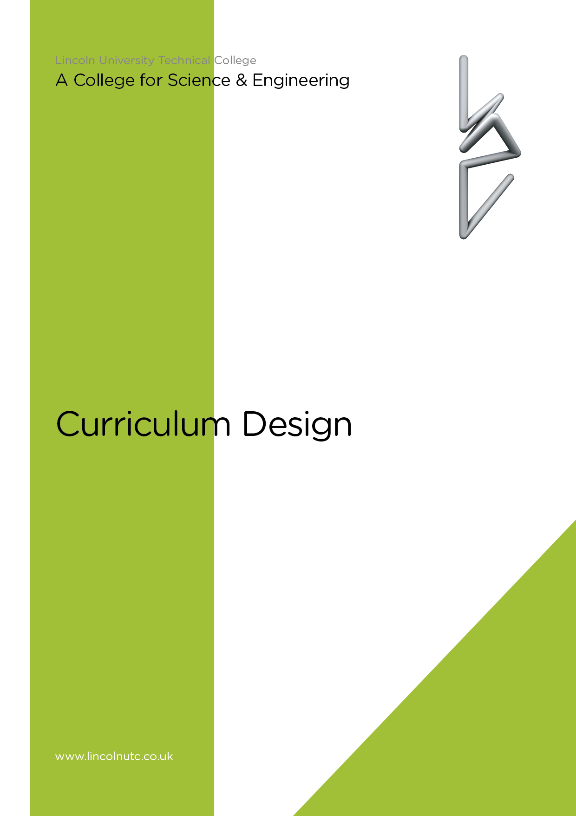

Equality and Diversity Statement

Lincoln UTC strives to treat all its members and visitors fairly and aims to eliminate unjustifiable discrimination on the grounds of gender, race, nationality, ethnic or national origin, political beliefs or practices, disability, marital status, family circumstances, sexual orientation, spent criminal convictions, age or any other inappropriate grounds.

Curriculum Design

Overarching Curriculum Aim

To provide a holistic education, enabling Lincoln UTC students to graduate as technically skilled, academically knowledgeable and highly motivated individuals with a passion for pursuing their chosen career pathway in science or engineering related fields.

Curriculum Overview

The curriculum at Lincoln UTC aims to promote and support the personal growth of the students towards physical, intellectual, emotional and spiritual maturity within a structured, cost effective, caring, creative, business focused, energetic and inspirational environment.

This is achieved through providing a balanced, relevant and interesting programme of study appropriate to each student within his or her chosen route of study, which is either Science, Engineering, Computer Science or Mathematics. Throughout the curriculum a range of experiences to promote individual responsibility and independence is integral to the learning experience, alongside independent, focused careers guidance and support in order to maximise achievement and long-term success.

Whilst the subjects will be delivered in their own specific timetabled slots, the subjects of Physics, Chemistry, Biology, Engineering and Mathematics has been structured to include regular industry-orientated projects. These project experiences will meet the needs of the curriculum content and also emulate the world of work and the challenges that are encountered there. These projects have been planned by UTC staff and industry experts, working alongside examiners to ensure the projects are highly relevant to meet the needs of all parties.

All other subjects will align their focus to promote both industry-focused and cross-curricular learning opportunities wherever possible. This will provide knowledge and understanding that is normally only obtained when in work, which therefore provides students with a greater level of understanding when applying for employment.

The varied and engaging mix of hands-on work experience and academic learning ensures that when students successfully complete the course, they are fully prepared to join the real world of work. Students will also receive weekly Life Guidance sessions, delivered by an our staff in conjunction with guest speakers and Careers Advisors. This advice will ensure our students’ academic and vocational learning is aligned to future career intentions and local opportunities. These Life Guidance sessions will complement work completed within all lessons and will ensure all students are supported to reflect on the development of their personal skills and qualities. These are vital and will ensure our students are truly successful in their future careers and lives. All students will leave the UTC with a Curriculum Vitae detailing their: academic qualification; technical qualifications and skills; personal skills and qualities.

Key Stage 4 Curriculum

It is vital that all Lincoln UTC students experience a broad and balanced curriculum whilst benefiting from extended depth and breadth of study in our specialist subject areas. Our curriculum design incorporates the key requirements for Progress 8 measurements and meets the needs of students of all abilities. The sections below outline our curriculum offer in greater detail.

Academic Core Curriculum

We ensure that our students develop the core skills of literacy and numeracy through studying the following GCSEs:

Subject | Qualification | Number of Qualifications
Mathematics | GCSE | 1
English Literature | GCSE | 1
English Language | GCSE | 1

Technical Core Curriculum

We ensure that all students gain a solid foundation of academic knowledge and technical expertise in our two specialisms, Science and Sustainable Engineering. Delivery of these subjects will focus on the context in industry to support learning and application. Visiting speakers and trips to industry partners will enhance learning in these critical curriculum areas.

Subject | Pathway | Qualification | No. Qualifications
Science | Combined Science  Separate Science from 2017/18 | GCSE  GCSE | 2  3
Engineering | Engineering | BTEC | 2

Option Subjects

It is important that our students are able to make decisions as to how they wish to broaden their learning experiences. In this phase of their academic development it is important to offer subjects both within and outside of our specialist subjects. The remaining subjects will provide students with critical skills required in industry and therefore make valuable contributions to their areas of expertise. Students are required to select two qualifications from the options below:

Subject from 2017/18 | Qualification
Computer Science | GCSE
Business Studies | BTEC
Engineering Design | GCSE

Key Stage 5 Curriculum

Introduction

Lincoln UTC provides pathways for each of our specialisms - Science and Engineering. These routes enable every student to follow a course that is best suited to their individual requirements.

Engineering

BTEC Extended Diploma in Engineering (3 A Level equivalent)
A Level

Students select 3 or 4 A Levels from the following:

A Level Specialist Options
Mathematics
Further Mathematics
Biology
Chemistry
Physics
Computer Science
Engineering (1 A Level equivalent)
Business Studies
Extended Project Qualification

The Wider Curriculum for all Students

Personal, Social, Citizenship, Health, Religious and Philosophical Education

In order to ensure our students receive holistic education the delivery of a bespoke curriculum package, to include the following areas, will be delivered:
- Personal development
- Social awareness
- Citizenship
- Healthy lifestyles
- Religious awareness
- Philosophical debate

These activities will be delivered through the following sessions:
- Student mentor sessions – Monday and Friday mornings
- Assemblies – Fortnightly
- Project sessions – Weekly
- Careers & Life Guidance (PSHE) lessons that are delivered – Weekly

Physical Education & Health

Lincoln UTC is committed to promoting the importance of a healthy mind and body and the need for an effective work-life balance. Therefore the inclusion of specific time for sporting activities to take place is vital. The range will adapt over the academic year and in accordance with the interests of students and specialisms of staff. However, we are committed to delivering a full range of activities.

Students will come together on one afternoon per week to utilise the facilities at a variety of local sporting venues including The University of Lincoln. The afternoon will enable students to participate in a range of activities which each contribute to good health. This will enable all participants to understanding the key components of healthy lifestyles, knowledge which is critical for post-UTC good health, well-being and happiness. They will be offered a variety of activities, which may include:

Basketball | Dance
Football | Wheelchair Basketball
Rugby | Weight Training
Badminton | Squash
Hockey | Tennis
Volleyball | Cricket

Careers Guidance & Industry Placements

Purpose: At Lincoln UTC each student has an entitlement to receive a comprehensive Careers Education, Information, Advice and Guidance (CEIAG) programme delivered by experienced and enthusiastic teaching staff. The CEIAG programme is supported by a number of partners that include Siemens, The University of Lincoln, Parents and the local Business Community. Students themselves are central to an effective programme and other professionals including Industry Leaders, Teachers, the Careers Coordinator and independent, impartial Careers Advisers also make a vital contribution to ensuring that UTC students develop the skills toolkit they need to make well-informed realistic decisions that will enable them to achieve their full potential in the future.

In order for students to truly appreciate the nature of work, they must experience it first hand. Students will have work-based experiences during the year at times appropriate for their studies and academic and personal development. Students will also devote time in their school holidays to conducting work based experiences and activities. The UTC, in conjunction with the students and their employers, will coordinate this. Students attend work placements at the following times during the academic year:

Year Group | Time of Year
Year 10 | April
Year 11 | October
Year 12 | July
Year 13 | February

Document Reviewed: Sept 2018

