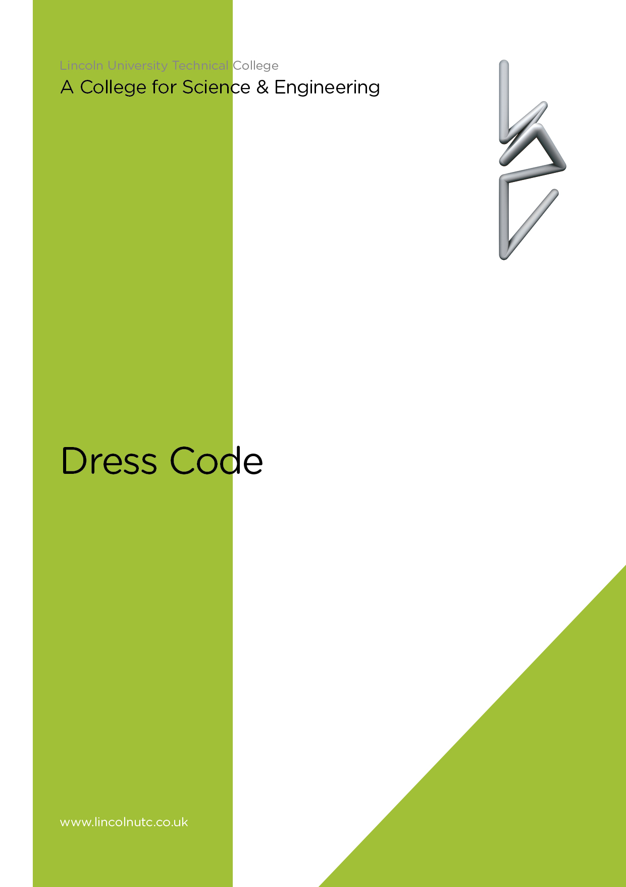
Equality and Diversity Statement

Lincoln UTC strives to treat all its members and visitors fairly and aims to eliminate unjustifiable discrimination on the grounds of gender, race, nationality, ethnic or national origin, political beliefs or practices, disability, marital status, family circumstances, sexual orientation, spent criminal convictions, age or any other inappropriate grounds.

Lincoln UTC

DRESS CODE

CONTENTS

Section | Contents
1 | Introduction
2 | Dress code
3 | Personal appearance
4  5 | Personal equipment  College bags

Lincoln UTC

DRESS CODE

1 Introduction

Lincoln UTC staff and students work collaboratively to develop professional, respectful relationships. The UTC is a place of learning. Members of the UTC dress and present themselves appropriately at all times, as would be expected in a business environment. Our attire meets the expectations of the environment we are working and learning in. By not having a school uniform, we are demonstrating the high value we place on individual pride, accountability and professionalism that lies at the heart of all we do.

2 dress code
The following business dress is deemed appropriate and professional for all staff and students at Lincoln UTC:
Classroom-based activities
Male:
- A matching, tailored suit, suitable for a professional environment; black ‘skinny jeans’/trousers are not permitted;
- A long or short sleeved shirt - coloured shirts are permitted;
- An appropriate tie;
- Words and diagrams on clothing should not be offensive or possibly be seen as offensive;
- Jumpers or cardigans should be knitted and plain; no sweatshirts or hooded sweatshirts should be worn; a suit jacket worn over jumpers or cardigans is still necessary;
- Smart, polished shoes or boots - open shoes, walking shoes/boots and flip flops are not suitable;
- Lincoln UTC pin badge;
- Outer coats and scarves to be removed inside the building.
Female:
- A dress or tailored skirt / trouser suit, suitable for a professional environment; black ‘skinny’ trousers/jeans are not permitted;
- The skirt/dress should be of a tailored, formal style; lycra or jersey skirts and dresses are not permitted;
- Tops/blouses suitable for a professional environment; low necked tops, vest tops and crop tops are not suitable;
- Words and diagrams on clothing should not be offensive or possibly be seen as offensive;
- Jumpers or cardigans should be plain - no sweatshirts or hooded sweatshirts should be worn;
- Smart, polished flat shoes or ankle boots - open shoes, walking shoes/boots, heels over two inches and flip flops are not suitable;
- Lincoln UTC pin badge;
- Outer coats and scarves to be removed inside the building.

Trainers are not permitted unless the need to wear them is supported by a Medical Note from a GP. Suitability of clothing will be at the Principal’s discretion. Please ask if you are unsure.
Workshop and Laboratory-based activities
Personal protective equipment (PPE) must be worn when working in laboratories and workshops.
The UTC will provide:
- a workshop coat;
- a laboratory coat;
- eye protection;
- ear protection.

Students will provide:
- safety shoes or boots.

Students in Year 12/13 following the BTEC in Applied Science or Engineering are welcome to borrow a laboratory or workshop coat from the UTC for their sole use.

Sports and PE Activities
During sports and PE activities students must wear appropriate sports clothing to reflect the activity they are taking part in. Students in Y10 who forget to bring the correct kit twice in a term will be placed in detention.

Lincoln UTC sports wear must be bought from our suppliers at Uniform Direct. They can be found at: www.uniform-direct.com

Students must wear shorts or tracksuit bottoms and a polo top. Only UTC sportswear is permitted – no other jumpers are acceptable. This is for safeguarding protocols to ensure that our sports coaches can easily spot our students during the off-site activities.

Appropriate sports footwear should be worn for all activities. Laced sports trainers with non-marking soles must be worn for all indoor activities. Football boots may be necessary if students select football or rugby as an option.

3 personal appearance
Jewellery should be kept to a minimum, consistent with good taste and safety. One ring, one watch and one necklace is the maximum jewellery permitted.

Apart from pierced ears, no other facial jewellery is permitted. Small stud earrings must be worn to comply with health and safety requirements in laboratories and workshops. These may need to be removed or covered for some practical activities. Ear stretchers are not permitted. Please note that students who are not dressed appropriately will be expected to remove excessive jewellery and it will be their responsibility to keep it safe.

Make up should be subtle. Hair and makeup should be of a style suitable for a professional environment; if hair is coloured it should be within the natural colour range.

4 PERSONAL EQUIPMENT

Students are expected to provide a full range of personal equipment required for their studies. This includes:

- Pencil case containing a suitable range of pens, pencils, 30cm ruler, eraser, sharpener, highlighters and other such stationery;
- Purple pen;
- Reading book;
- Scientific calculator;
- 2H and 4H drawing pencils for Engineering lessons;
- Personal diary or electronic device to record notes, diary entries and preparatory work.

5 College bags

Bags should be either a waterproof rucksack or messenger style bag, without extreme logos.

They should fulfil the following functions:

- hold A4 size file items/stationary;
- fasten securely;
- support the back;
- be weatherproof to protect items during travel to and from the UTC;
- protect your IT device safely (if applicable).

Document reviewed: Sept 2018

